Relational Database Project

Parts 4&5:Loading data into tables & Creating views

Contents

Problem Statement 4

Analysis (Explanation of “Part4_Load Data into Tables.sql” file) 5

Results (Screenshots of “Part4_Load Data into Tables.sql” file) 18

Analysis (Explanation of “Part5_Create Views.sql” file) 21

Results (See “Part3,4,5 (Rev1).sql” to view the sql code) 45

Redone Analysis (Changes in going from Rev1 to Rev2) 46

Redone Results (See “Part3,4,5 (Rev2).sql” to view the sql code) 48

# Problem Statement

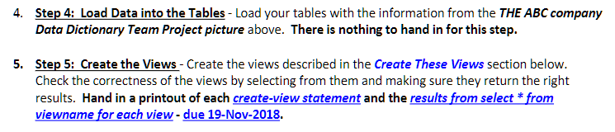

# Analysis (Explanation of “Part4_Load Data into Tables.sql” file)

* From Part3_Create Table.sql we can see the list of tables containing entities only (excludign relationship tables)

|  |  |
| --- | --- |
| **Part3_Create Table.sql**  **(containing all the entities tables only)** | **Comments (Does it exist in Part4_Load Data into Tables.sql)** |
| All Entities | **Yes** it exists on Part4; because ABC Diagram contains entities |
| All Attributes | **Yes** it exists on Part4; because ABC Diagram contains attributes |
| All Keys | **Yes** it exists on Part4; because ABC Diagram contains key attributes |
| Inheritance | **Yes** it exists on Part4; because ABC Diagram contains inheritance relationship |
| Entity Attributes | **No** it doesn’t exist on Part4; using Entity Attributes causes redundant data entry because both (All Entities & Entities Attributes) have the same attribute (AttributeName) as the PK from Part3_CreateTable.sql |
| Relationship Attributes | **No** it doesn’t exist on Part4; using Entity Attributes causes redundant data entry because both (All Entities & Relationship Attributes) have the same attribute (AttributeName) as the PK from Part3_CreateTable.sql |
| **Part3_Create Table.sql (Containing relationship tables only)** | **Comments (Why or why it doesn’t exist in Part4_Load Data into Tables.sql)** |
| All Relationships | **Yes** it exists on Part4; because ABC Diagram contains relationships |
| AllEntities_Has_AllAttributes | **Yes** it exists on Part4; because ABC Diagram contains entities that have attributes |
| AllEntities_Has_AllRelationships | **Yes** it exists on Part4; because ABC Diagram contains entities that have relationships |
| AllRelationships_Has_RelationshipAttributes | **Yes** it exists on Part4; because ABC Diagram contains relationships that have attributes |
| All AttributesAttributeTypes | **No** it doesn’t exists on Part4;doesn’t model any meaningful or unique characteristics of the ABC Diagram. |
| AllEntities_Has_AllKeys | **No** it doesn’t exists on Part4; using AllEntities_Has_AllKeys causes redundant data entry because the PK of the AllEntities_Has_AllKeys Table is (Entity Name, Attribute Name) which is the same as the PK of (AllEntities & All Attributes) Tables from Part3_CreateTable.sql |

Filtering the table above to see yes only

|  |  |
| --- | --- |
| **Part3_Create Table.sql**  **(containing all the entities tables only)** | **Comments (Does it exist in Part4_Load Data into Tables.sql)** |
| All Entities | **Yes** it exists on Part4; models unique characteristics of the ABC Diagram |
| AllRelationships_Has_RelationshipAttributes | **Yes** it exists on Part4; models unique characteristics of the ABC Diagram |
| All Attributes | **Yes** it exists on Part4; models unique characteristics of the ABC Diagram |
| All Keys | **Yes** it exists on Part4; models unique characteristics of the ABC Diagram |
| Inheritance | **Yes** it exists on Part4; models unique characteristics of the ABC Diagram |
| All Relationships | **Yes** it exists on Part4; models unique characteristics of the ABC Diagram |
| AllEntities_Has_AllAttributes | **Yes** it exists on Part4; models unique characteristics of the ABC Diagram |
| AllEntities_Has_AllRelationships | **Yes** it exists on Part4; models unique characteristics of the ABC Diagram |

* Loading Data into AllEntities Table
  + Extracted entities from the ABC Diagram and loading it as data into the table using INSERT sql statements

|  |
| --- |
| **ABC Diagram** |
|  |
| **SQL Syntax: INSERT INTO <tablename> VALUES <attribute list>** |
| Part3_Create Tables.sql    Part4_Load Data into Tables.sql |

* Loading Data into AllRelationships_Has_RelationshipAttributes Table
  + Extracted relationship attributes from the ABC Diagram and loading it as data into the table using INSERT sql statements

|  |
| --- |
| **ABC Diagram** |
|  |
| **SQL Syntax: INSERT INTO <tablename> VALUES <attribute list>** |
| Part3_Create Tables.sql    Part4_Load Data into Tables.sql |

* Loading Data into AllAttributesTable
  + Extracted entity attributes from the ABC Diagram and loading it as data into the table using INSERT sql statements

|  |
| --- |
| **ABC Diagram** |
|  |
| **SQL Syntax: INSERT INTO <tablename> VALUES <attribute list>** |
| Part3_Create Tables.sql    Part4_Load Data into Tables.sql |

* Loading Data into AllAttributesTable
  + Linking the entities to their correct entity attributes based on the ABC Diagram and loading it as data into the table using INSERT sql statements

|  |
| --- |
| **ABC Diagram** |
|  |
| **SQL Syntax: INSERT INTO <tablename> VALUES <attribute list>** |
| Part3_Create Tables.sql    Part4_Load Data into Tables.sql |

* Loading Inheritance Relationship Data into Inheritance Table
  + Loading the inheritance relationship (“Employee **IS A** Associate or a Temp Hourly” and also “TempHourly **IS A** Contractor” ) as data into the table using INSERT sql statements

|  |
| --- |
| **ABC Diagram** |
|  |
| **SQL Syntax: INSERT INTO <tablename> VALUES <attribute list>** |
| Part3_Create Tables.sql    Part4_Load Data into Tables.sql |

* Loading (Relationship with cardinalities) Data into AllRelationships Table
  + Extracted all the (relationships with cardinalities) from the ABC Diagram and loading it as data into the table using INSERT sql statements

|  |
| --- |
| **ABC Diagram** |
|  |
| **SQL Syntax: INSERT INTO <tablename> VALUES <attribute list>** |
| Part3_Create Tables.sql    Part4_Load Data into Tables.sql |

* Loading Data into AllKeysTable
  + Extracted (Keytype, Keyname) attributes for all the key attributes from the ABC Diagram and loading it as data into the table using INSERT sql statements

|  |
| --- |
| **ABC Diagram** |
|  |
| **SQL Syntax: INSERT INTO <tablename> VALUES <attribute list>** |
| Part3_Create Tables.sql    Part4_Load Data into Tables.sql |

* Loading Data into AllEntities_Has_AllKeys Table
  + Extracted (Entity Name, AttributeName) attributes for all the key attributes from the ABC Diagram and loading it as data into the table using INSERT sql statements

|  |
| --- |
| **ABC Diagram** |
|  |
| **SQL Syntax: INSERT INTO <tablename> VALUES <attribute list>** |
| Part3_Create Tables.sql    Part4_Load Data into Tables.sql |

# Results (Screenshots of “Part4_Load Data into Tables.sql” file)

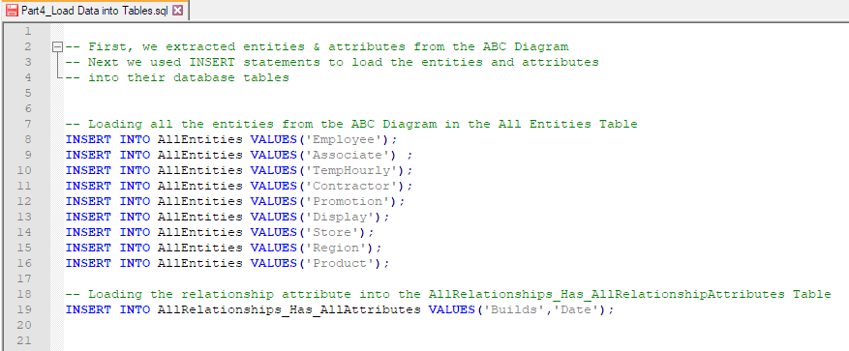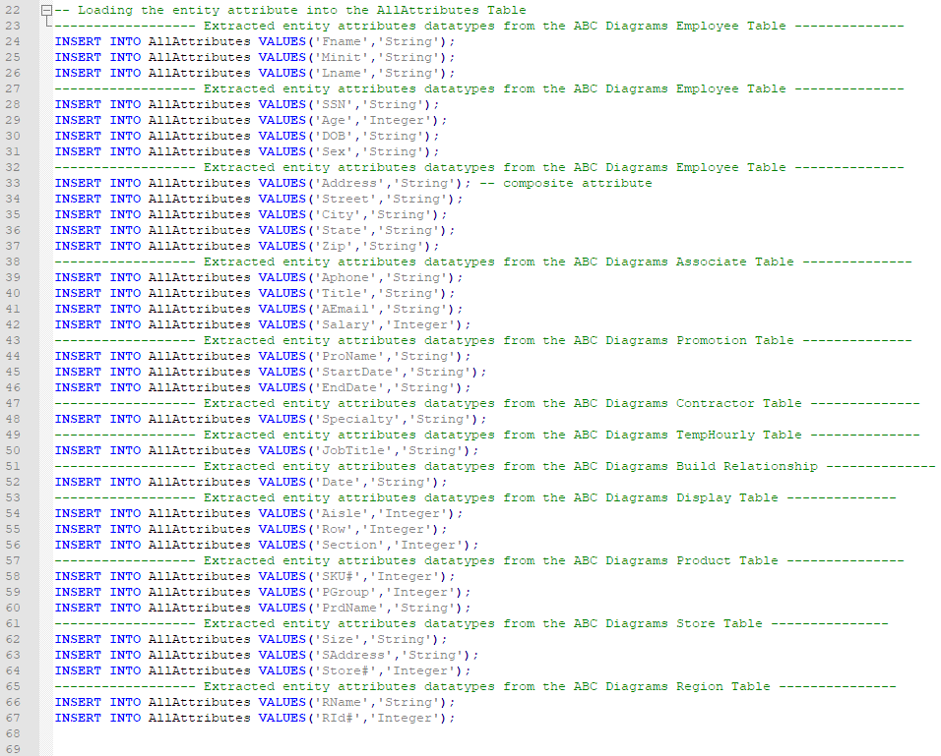

# 

# 

# 

# Analysis (Explanation of “Part5_Create Views.sql” file)

View1 Query (Screenshot pulled from Part5_Create Views.sql file)

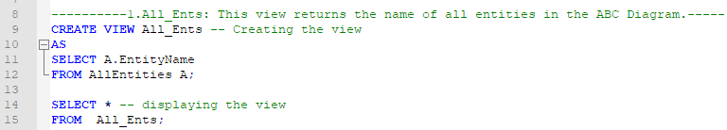

Oracle SQL Developer (Visually verifying View1 queries output)

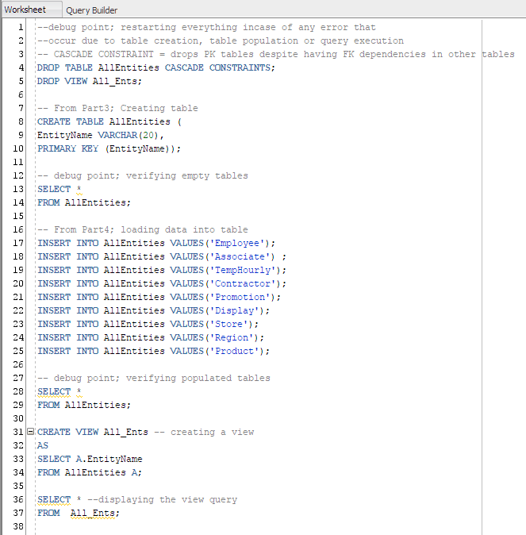

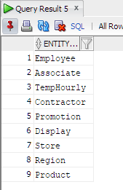

View2 Query (Screenshot pulled from Part5_Create Views.sql file)

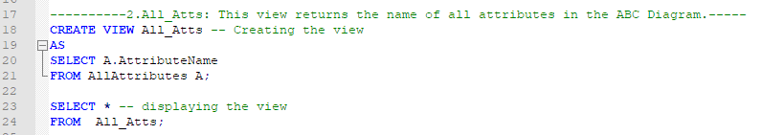

Oracle SQL Developer (Visually verifying View2 queries output)

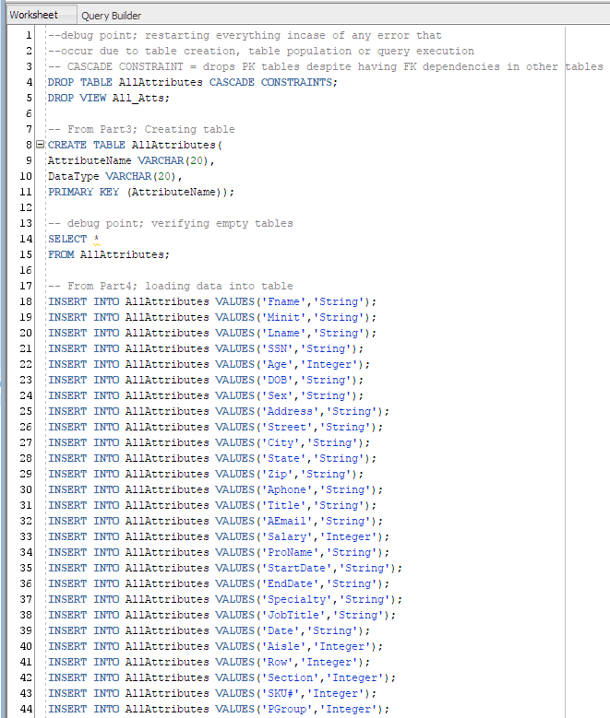

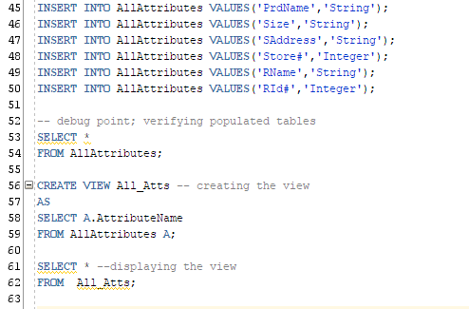

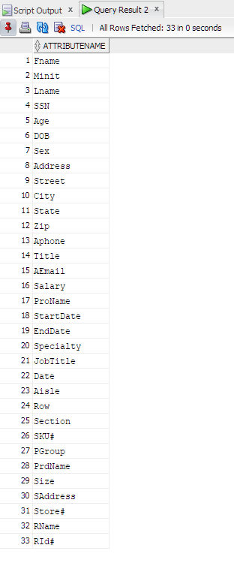NAME is missing

View3 Query (Screenshot pulled from Part5_Create Views.sql file)

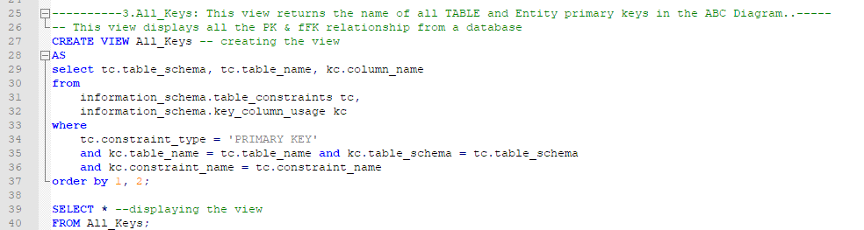

Oracle SQL Developer (Visually verifying View3 queries output)

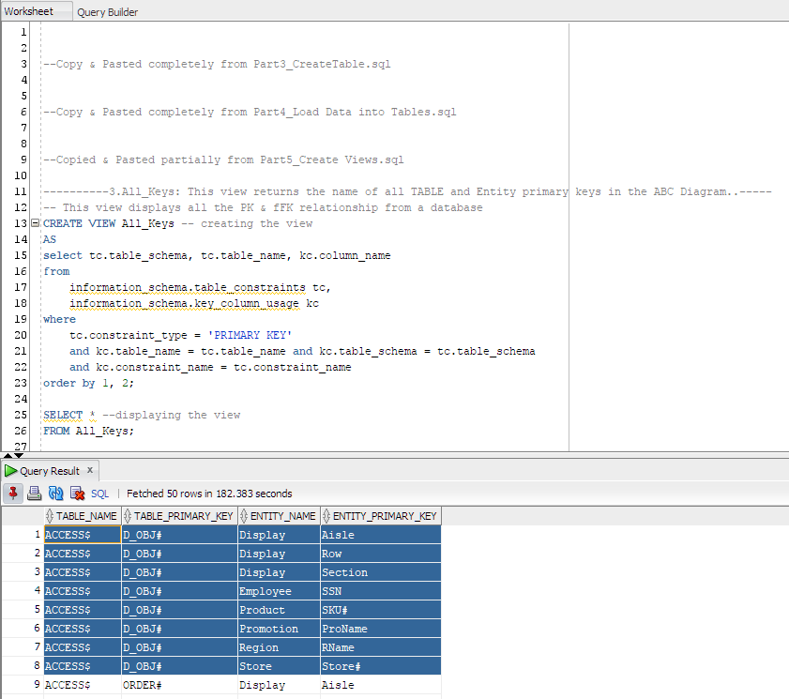

Still MISSING the other underlined attributes from the picture

View4 Query (Screenshot pulled from Part5_Create Views.sql file)

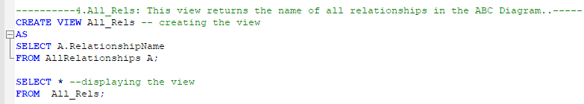

Oracle SQL Developer (Visually verifying View4 queries output)

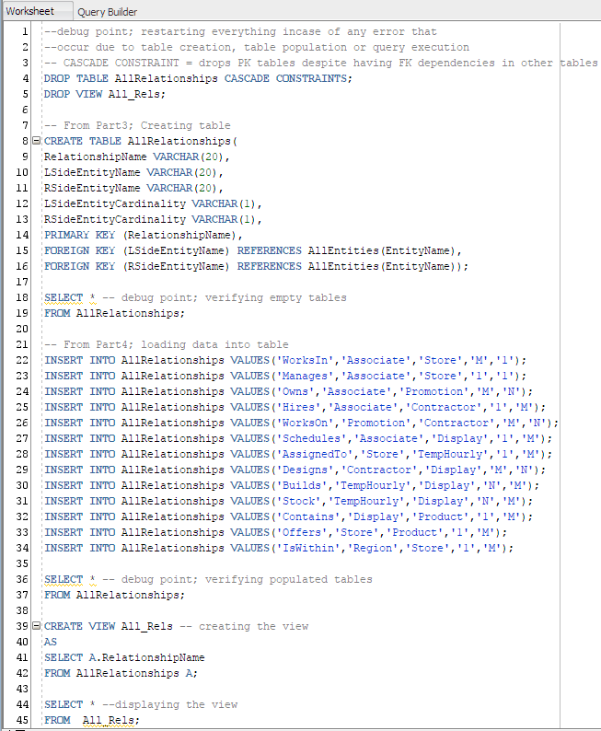

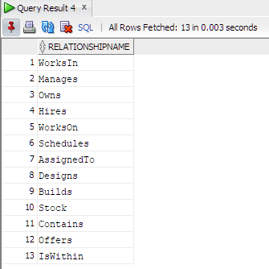

How do you handle the D relationships?

View5 Query (Screenshot pulled from Part5_Create Views.sql file)

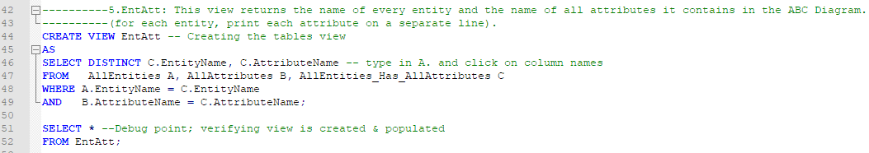

Oracle SQL Developer (Visually verifying View5 queries output)

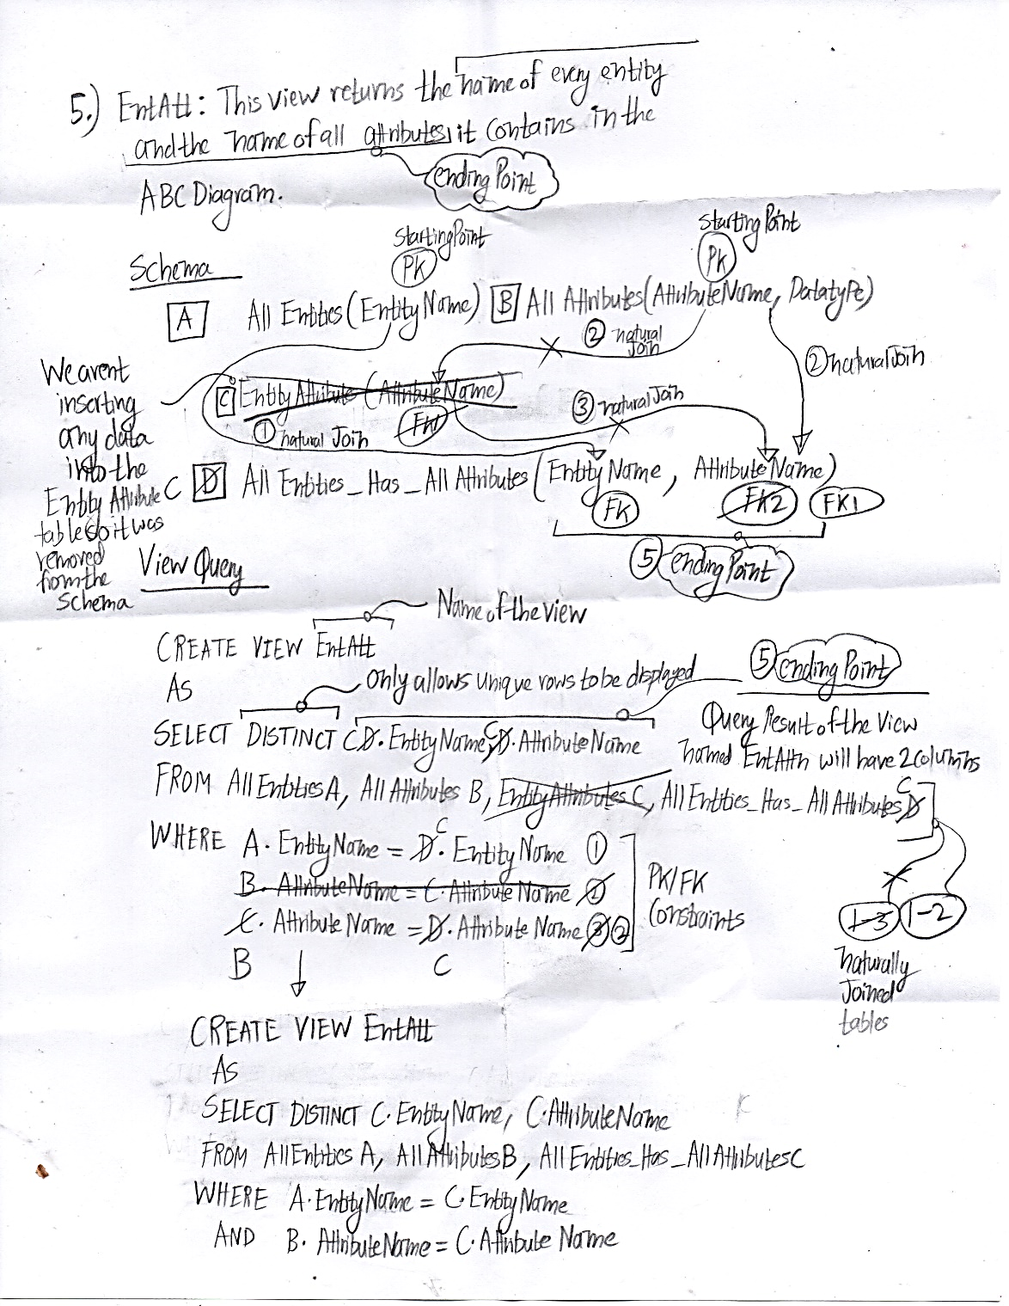

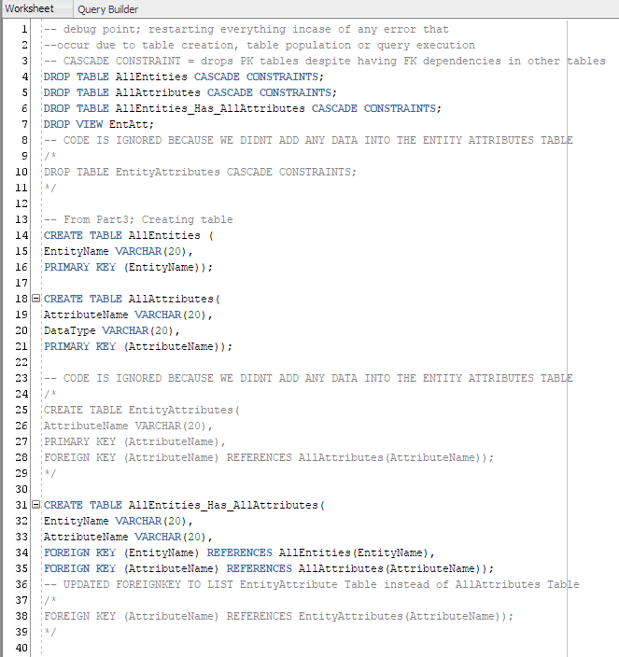

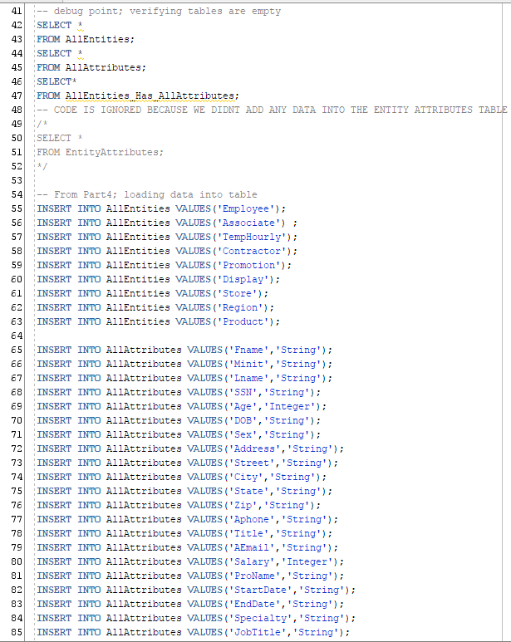

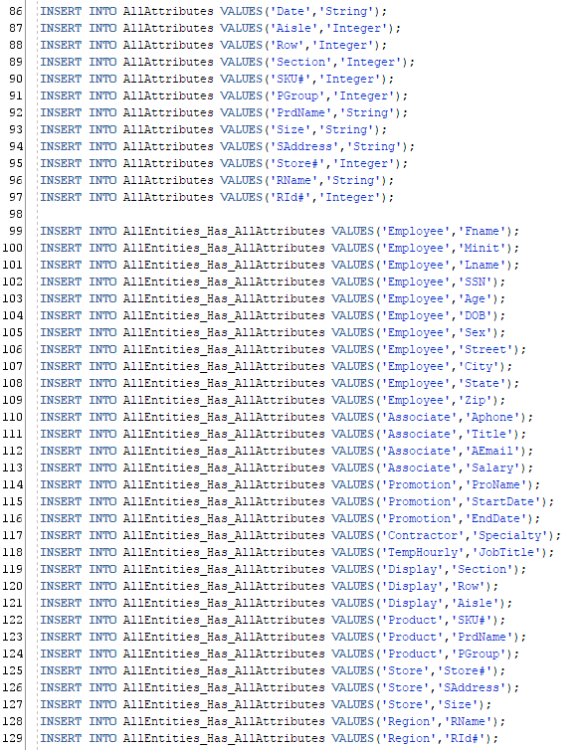

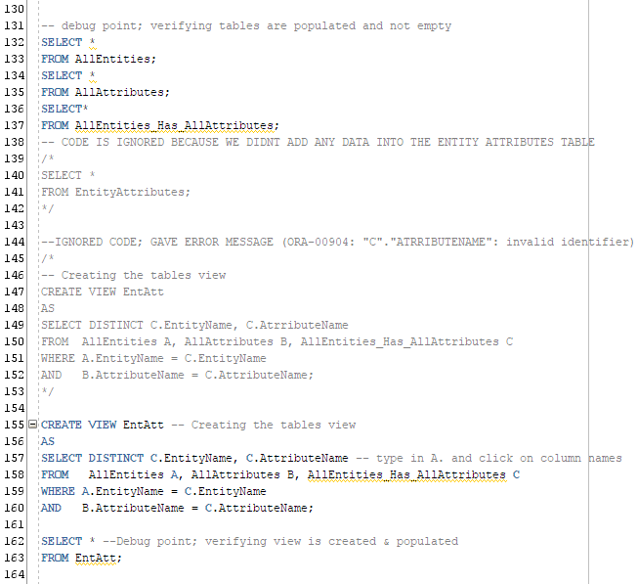

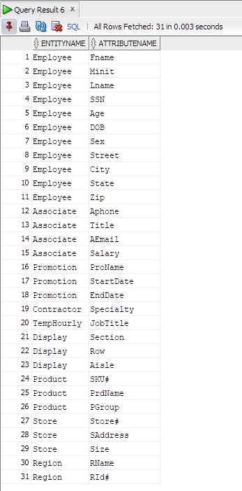

Name and Address are missing

View6 Query (Screenshot pulled from Part5_Create Views.sql file)

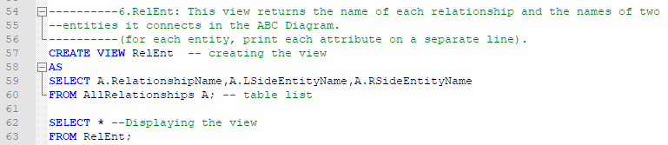

Oracle SQL Developer (Visually verifying View6 queries output)

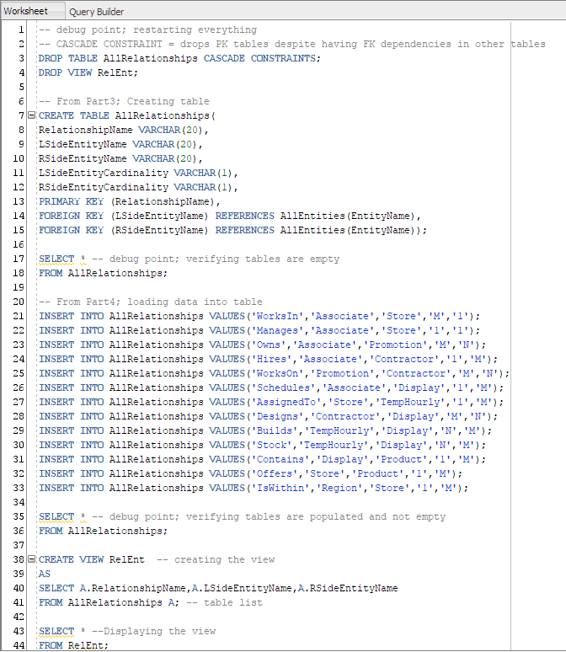

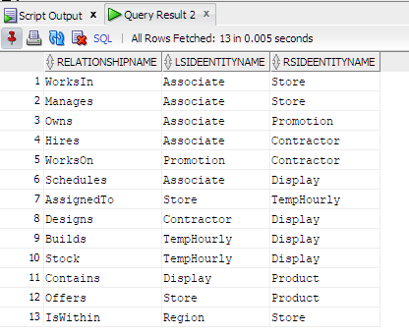

How about the Ds?

View7 Query (Screenshot pulled from Part5_Create Views.sql file)

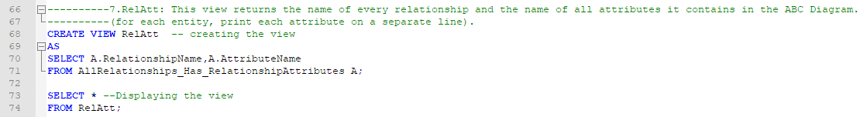

Oracle SQL Developer (Visually verifying View7 queries output)

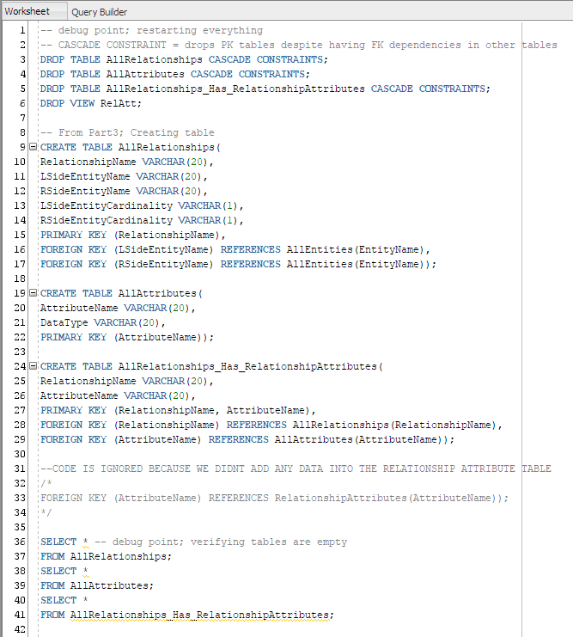

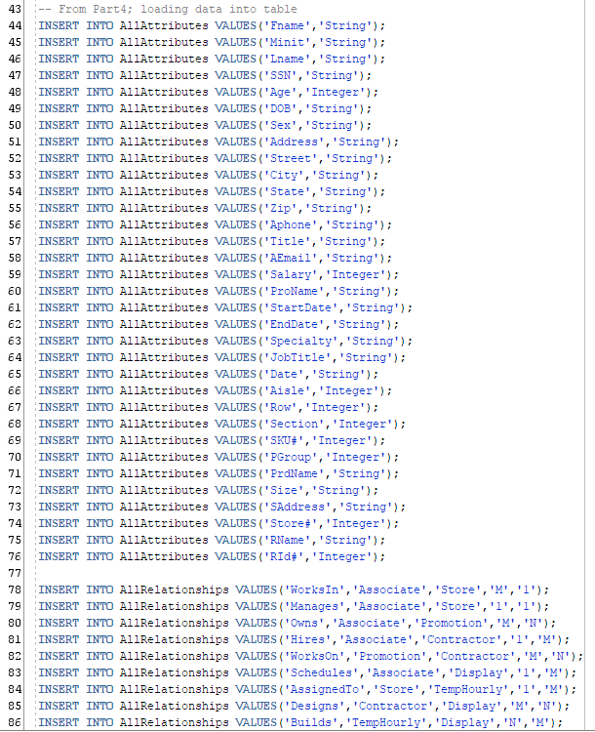

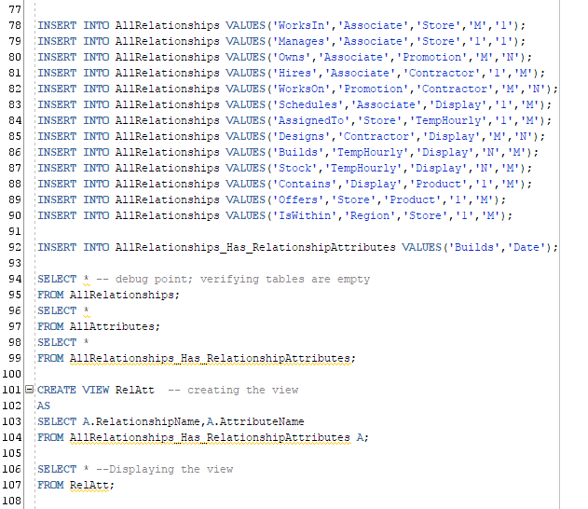

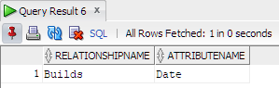

View8 Query (Screenshot pulled from Part5_Create Views.sql file)

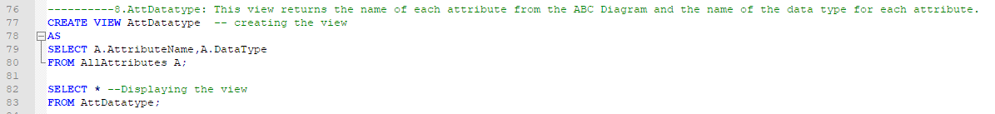

Oracle SQL Developer (Visually verifying View8 queries output)

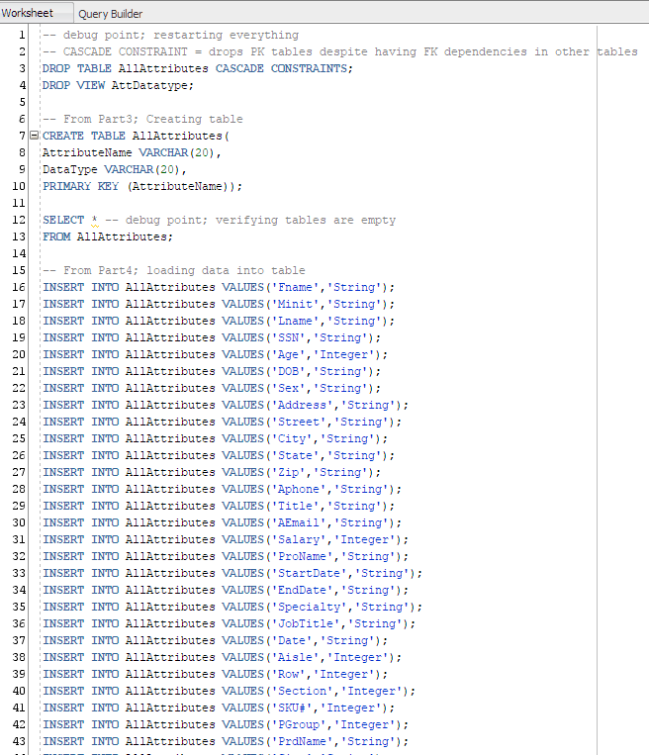

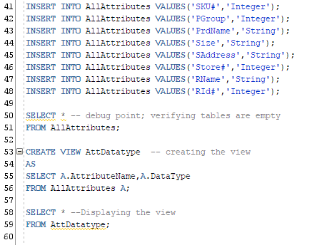

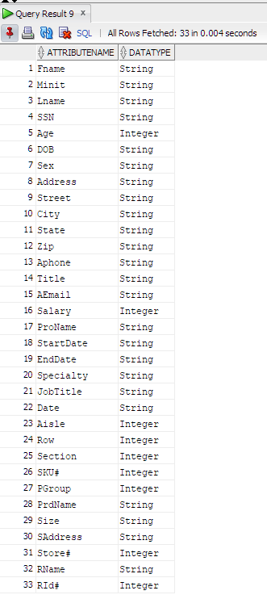Name is missing

View9 Query (Screenshot pulled from Part5_Create Views.sql file)

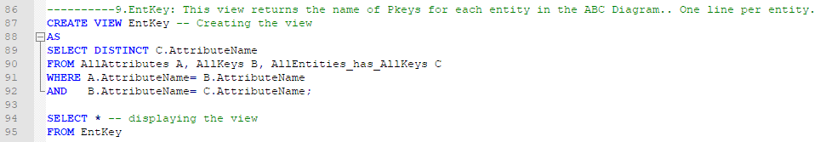

Oracle SQL Developer (Visually verifying View9 queries output)

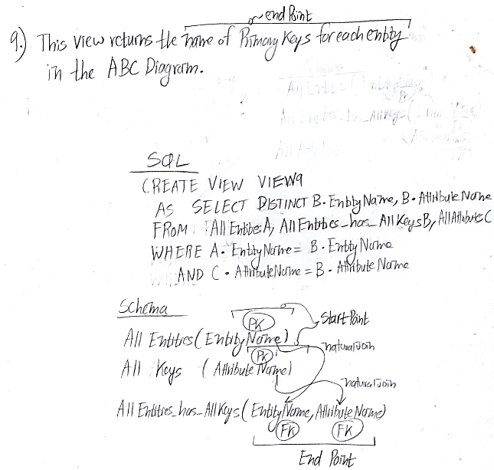

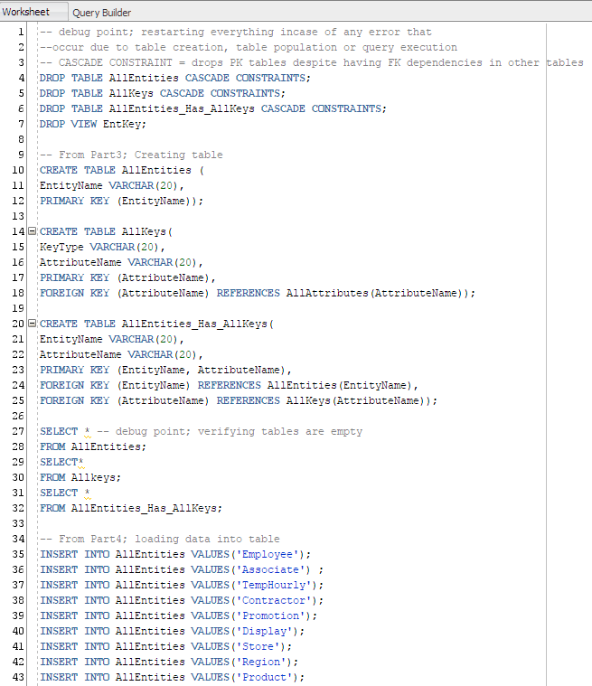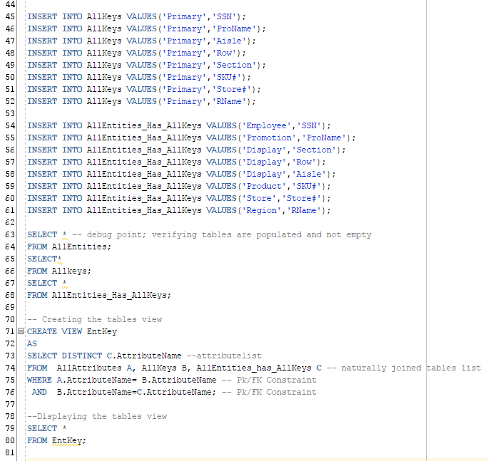

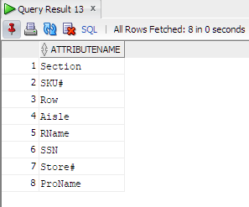

View10 Query (Screenshot pulled from Part5_Create Views.sql file)

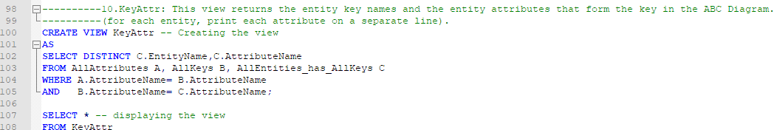

Oracle SQL Developer (Visually verifying View10 queries output)

